Introduction
Completed100 XP
- 3 minutes
Eventstreams enable you to capture and process real-time events without needing to write any code. You can set up event sources, destinations, and transformations in the event stream; enabling you to collect, filter, aggregate, group, and combine data from real-time sources before loading it into a destination.
Some of the main benefits of Microsoft Fabric Eventstreams are:
- You can capture, transform, and route real-time events to various destinations with a no-code experience. You can use the drag and drop feature to make your event data processing logic without writing any code.
- There are multiple source connectors to get event data from different sources, such as Azure Event Hubs, Azure IoT Hub, Azure storage, Apache Kafka, and others.
- You can send data to a wide range of destinations for further analysis or processing. You can attach multiple destinations in an eventstream to ingest data from a single source into multiple stores.
- Eventstreams uses a scalable infrastructure that manages resources automatically. The scalable infrastructure helps you capture your real-time events easily, making streaming ETL (Extract, Transform, Load) operations possible.
In this module, you'll learn how to create eventstreams and use them to ingest and transform a real-time stream of data, and route it to destinations for further processing and analysis.

Components of eventstreams
Completed100 XP
- 10 minutes
Microsoft Fabric eventstreams work by creating a pipeline of events from multiple internal and external sources to different destinations. You can think of it as a conveyor belt that moves data from one place to another. You can also add some transformations to the data along the way, such as filtering, aggregating, or enriching.
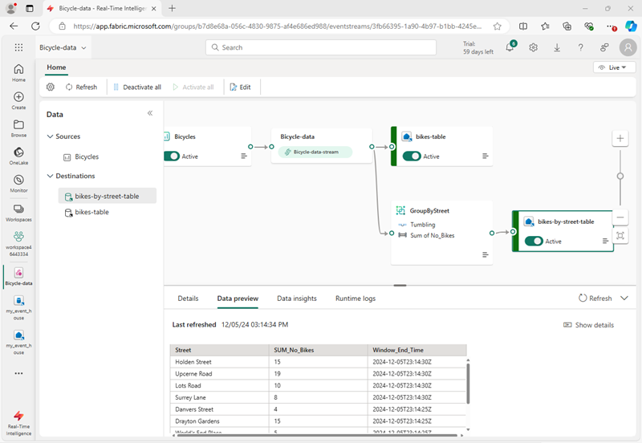
You can use the eventstream visual editor to design your pipeline by dragging and dropping different nodes, such as sources, destinations, and transformations. You can also see the event data flowing through the pipeline in real-time. Microsoft Fabric eventstream handles the scaling, reliability, and security of your event stream automatically. You don’t need to write any code or manage any infrastructure to use Microsoft Fabric Eventstream.
The main components of an eventstream are:
- Sources: Sources are where your event data comes from. You can pick Azure Event Hubs, sample data, or custom app as your source type. You can also choose the data format and the consumer group of your source.
- Transformations: You can add transformations that filter or aggregate the data as is processed from the stream. Transformations include common data operations such as filtering, joining, aggregating, and grouping as well as temporal windowing functions that enable you to analyze data events within discrete time periods.
- Destinations: Destinations are where your transformed event data is stored. For example, you can store the results of your stream processing in a table in an eventhouse or a lakehouse, or you could redirect data to another eventstream for further processing or to an activator to trigger an action.
You can use the eventstream editing canvas to add and manage your sources and destinations. You can also see the event data, check the data insights, and view logs for each source or destination.

Eventstream sources and destinations
Completed100 XP
- 10 minutes
At their simplest, eventstreams capture real-time data from a source and load the captured data into a destination.

Eventstream sources
Event sources in Fabric Real-Time Hub can include (among others):
- Azure Event Hub: Azure Event Hubs is a source that allows you to get event data from an Azure event hub. You can specify the data format and the consumer group of your Azure event hub. You can also create a cloud connection to your Azure event hub with the appropriate authentication and privacy level.
- Azure IoT Hub: An SaaS service used to connect, monitor, and manage millions of IoT assets with a no-code experience.
- Azure SQL Database Change Data Capture (CDC): Software process that identifies and tracks changes to data in a database, enabling real-time or near-real-time data movement.
- PostgreSQL Database CDC: The PostgreSQL Database CDC (change data capture) connector for Microsoft Fabric Eventstreams captures a current snapshot and tracks future changes in a PostgreSQL database, allowing real-time processing and analysis of this data within Fabric.
- MySQL Database CDC: The Azure MySQL Database CDC Source connector for Microsoft Fabric Eventstreams captures a snapshot of your MySQL database and tracks table changes, enabling real-time processing and analysis of this data in Fabric.
- Azure Cosmos DB CDC: The Azure Cosmos DB CDC connector for Microsoft Fabric Eventstreams captures and tracks real-time data changes in Cosmos DB for analysis and processing within Fabric.
- Google Cloud Pub/Sub: A messaging service for exchanging event data among applications and services.
- Amazon Kinesis Data Streams: Collect, process, and analyze real-time, streaming data.
- Confluent Cloud Kafka: A fully managed service based on Apache Kafka for stream processing.
- Fabric workspace events: Fabric workspace events are events triggered by changes in your Fabric Workspace, such as creating, updating, or deleting items. With Fabric event streams, you can capture, transform, and route these events for in-depth analysis and monitoring within Fabric. This integration offers enhanced flexibility in tracking and understanding workspace activities.
- Azure blob storage events: Azure Blob Storage events are system triggers for actions like creating, replacing, or deleting a blob. Microsoft Fabric eventstreams link these actions to Fabric events, allowing you to process Blob Storage events as continuous data streams for routing and analysis within Fabric. One unique trait of the Azure Blob Storage Events is their support for streamed or unstreamed events.
- Custom endpoint: You can use the REST API or software development kits (SDKs) provided by Microsoft Fabric to send event data from your custom app to your eventstream. You can also specify the data format and the consumer group of your custom app.
- Sample data: Sample data is a source that allows you to use the out-of-box sample data provided by Microsoft Fabric. You can choose from different sample data sets, such as IoT, Retail, or Finance. You can also adjust the frequency and duration of the sample data generation.
Tip
For more information about supported sources, see Supported sources for Fabric Real-Time hub.

Eventstream destinations
Microsoft Fabric event streams also supports the ability to send data to the following destinations in the enhanced mode.
- Eventhouse: This destination offers the capability to funnel your real-time event data into a KQL database, enabling you to use Kusto Query Language (KQL) for data interrogation and analysis. Storing your data in a KQL database unlocks the potential for enhanced comprehension of your event data and the creation of comprehensive reports and dashboards.
- Lakehouse: This destination empowers you to preprocess your real-time events before their ingestion into your lakehouse. The events are transformed into Delta Lake format and later stored in specific lakehouse tables, facilitating your data warehousing needs.
- Custom endpoint: With this feature, you can seamlessly direct your real-time event traffic to a bespoke application. It enables the integration of your proprietary applications with the event stream, allowing for the immediate consumption of event data. This feature is advantageous when you aim to transfer real-time data to an independent system not hosted on the Microsoft Fabric.
- Derived Stream: The derived stream is a specialized destination created post-application of stream operations like Filter or Manage Fields to an eventstream. It represents the altered default stream after processing, which can be routed to various destinations within Fabric and monitored in the Real-Time hub.
- Fabric Activator: This destination enables you to use Fabric Activator to trigger automated actions based on values in your streaming data.
Tip
For more information about supported sources, see Add and manage a destination in an eventstream.
You can attach to multiple destinations within an event stream at the same time without impacting or colliding with each other.

Eventstream transformations
Completed100 XP
- 10 minutes
The drag and drop eventstream editing interface offers a straightforward and user-friendly method for constructing complex event data processing workflows.

Eventstream transformations
You can transform data in an eventstream by applying the following transformations:
- Filter: Use the Filter transformation to filter events based on the value of a field in the input. Depending on the data type (number or text), the transformation keeps the values that match the selected condition, such as is null or is not null.
- Manage fields: This transformation allows you to add, remove, change data type, or rename fields coming in from an input or another transformation.
- Aggregate: Use the Aggregate transformation to calculate an aggregation (Sum, Minimum, Maximum, or Average) every time a new event occurs over a period of time. This operation also allows for the renaming of these calculated columns, and filtering or slicing the aggregation based on other dimensions in your data. You can have one or more aggregations in the same transformation.
- Group by: Use the Group by transformation to calculate aggregations across all events within a certain time window. You can group by the values in one or more fields. It's like the Aggregate transformation allows for the renaming of columns, but provides more options for aggregation and includes more complex options for time windows. Like Aggregate, you can add more than one aggregation per transformation.
- Union: Use the Union transformation to connect two or more nodes and add events with shared fields (with the same name and data type) into one table. Fields that don't match are dropped and not included in the output.
- Expand: Use this array transformation to create a new row for each value within an array.
- Join: this join is a transformation to combine data from two streams based on a matching condition between them.

Windowing functions in Eventstream
Windowing functions are a way to perform operations on the data contained in temporal windows, such as aggregating, filtering, or transforming streaming events that occur within a specified time period. Windowing functions are useful for analyzing streaming data that changes over time, such as sensor readings, web-clicks, on-line transactions, and more and provide great flexibility to keep an accurate record of events as they occur.
Earlier, we mentioned the Group by operator in the event processor editor. This graphical interface allows us to define the logic we need for processing, transforming, and routing event data. There are four parameters that need specified in the Group by operator settings to use these windowing functions that include:
- The window type, which can be tumbling, sliding, snapshot, hopping, or session.
  - tumbling windows divides incoming events into fixed and nonoverlapping intervals based on arrival time.
This window shows a count of tweets per time zone every 10 seconds apart.
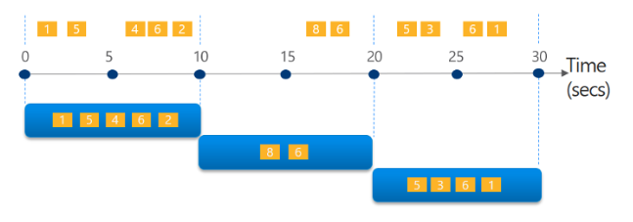
  - sliding windows takes the events into fixed and overlapping intervals based on time and divides them.
A window is a 10-second sliding window that alerts the user whenever an article is mentioned more than three times in under 10 seconds
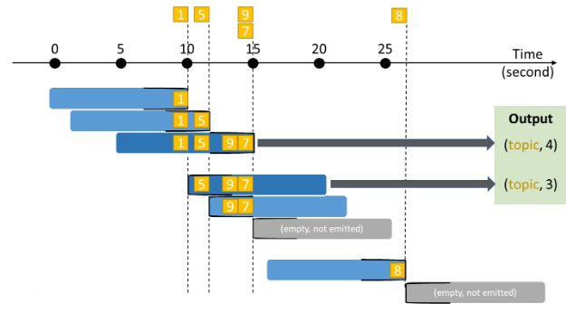
Note
All of the tweets belong to the same topic in this scenario
  - session windows simply divides events into variable and nonoverlapping intervals that are based on a gap of lack of activity.
A window, which shows the total count of tweets that occur within five minutes of one another
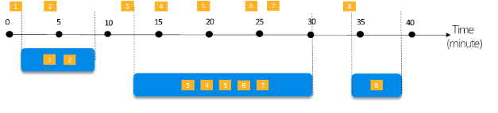
  - hopping windows hopping windows are different from tumbling windows as they model scheduled overlapping window.
A 10 second hopping window, which refreshes every 5 seconds and provides the total count of tweets over the past 10 seconds.
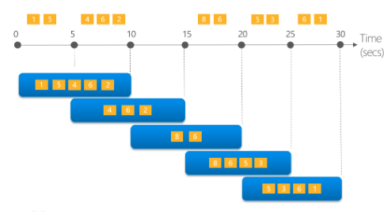
  - snapshot windows snapshot windows group event stream events that have the same timestamp and are unlike the other windowing functions, which require the function to be named. In snapshot windows you add the System.Timestamp() to the GROUP BY clause.
This window provides a count of tweets with the same article type that occur at exactly the same time.
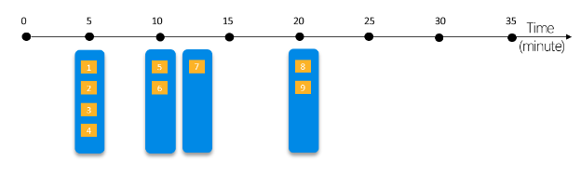
- The window duration is the length of each window interval, which can be in seconds, minutes, hours, and even days. An example duration, such as 10 minutes, means simply that each window covers 10 minutes of event data.
- The window offset is an optional parameter that shifts the start and end of each window interval by a specified amount of time. An example of when this optional parameter is set might be a window offset of 2 minutes, which means that each window starts and ends 2 minutes later than usual.
- The grouping key is one or more columns in your event data that you wish to group by. For example, by sensor ID, or item category.
- The Aggregation function is one or more of the functions that you want to apply to each group of events in each window. Where the counts, sums, averages, min/max, and even custom functions become useful.

ANOTHER MODULE

Work with real-time data in a Microsoft Fabric eventhouse

Introduction
Completed100 XP
- 3 minutes
An eventhouse in Microsoft Fabric provides a data store for large volumes of data. An eventhouse is optimized for data that represents time-based events, as is common in real-time data analytics scenarios. They're designed to handle real-time data streams efficiently, which enables organizations to query and analyze data in near real-time.
It's common in Microsoft Fabric to use an eventstream to load a stream of real-time data into an eventhouse. You can then:
- Query the data using Kusto Query Language (KQL) or a subset of Structured query Language (SQL) in a KQL Queryset.
- Use Real-Time Dashboards to visualize the data.
- Use Fabric Activator to automate actions based on the data.
An eventhouse is the Fabric data store at the center of all of these capabilities.
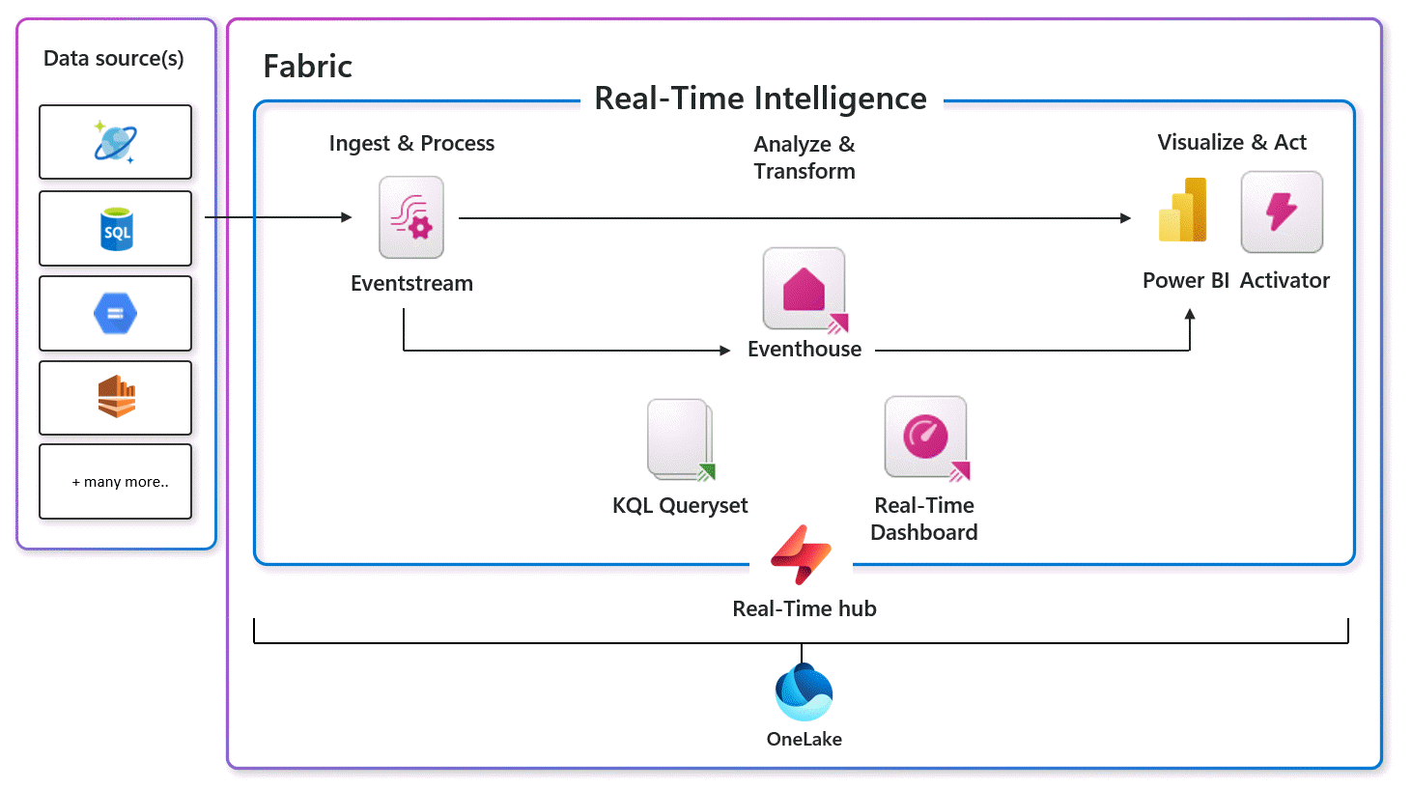

Get started with an eventhouse
Completed100 XP
- 12 minutes
To create an eventhouse, you must be working on a workspace with a Fabric capacity that supports the Real-Time Intelligence Fabric capability. You can then create one or more eventhouses for your data.
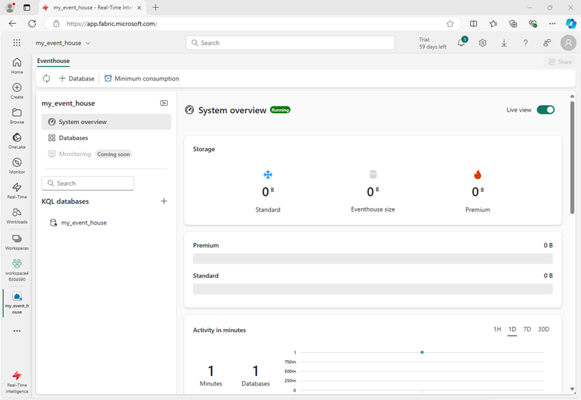
An eventhouse contains one or more KQL databases, in which you can create tables, stored procedures, materialized views, and other items to manage your data. After creating an eventhouse, you can use the default KQL database or create a new one.
To get your data into a KQL database in an eventhouse, you typically import it from a static location (such as a local file, OneLake, Azure storage, or a sample dataset) or from a real-time source (such as Azure Event Hubs or a Fabric eventstream).
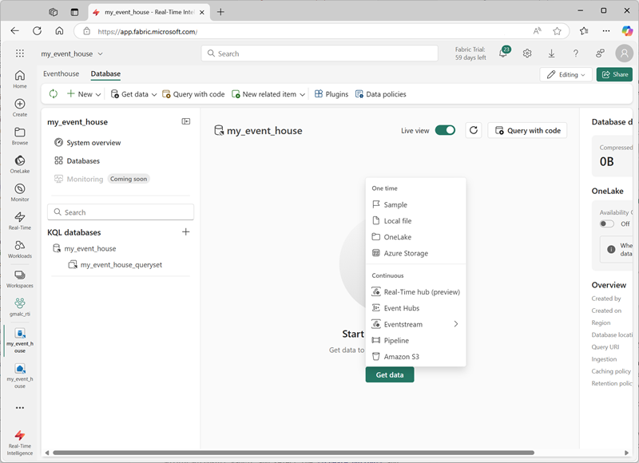
Note
You can enable the OneLake option for a database or for individual tables it contains, making the data from these tables available in OneLake.

Querying tables in a KQL database
To query data in the tables in a KQL database, you can write Kusto Query Language (KQL) code or use a restricted subset of Structured Query Language (SQL) statements.
To make it easier to develop queries, eventhouses include support for one or more KQL Queryset, which simplify query development by providing sample syntax and coding utilities. A default queryset is provided, and you can create more if needed.
KQL syntax is intuitive and concise, and includes a wide range of functions and expressions that make it easy to perform complex data analysis efficiently.
The simplest KQL query consists simply of a table name. For example, to retrieve all of the data from a table named Automotive, you could run the following query:
kqlCopy
Automotive
This KQL query is the equivalent of the SQL expression SELECT * FROM Automotive.
Given the potentially huge size of tables based on unbounded streams of real-time data, using a simple table name query is unusual. If you want to retrieve a sample of data from the table, you can use the take keyword, as shown here:
kqlCopy
Automotive
| take 100
This query returns 100 rows from the Automotive table (similarly to the SQL SELECT TOP 100 * FROM Automotive). Note the use of the | character on each new line to separate the clauses of the query.
Here are some common queries and their SQL equivalents

Retrieve specific columns
kqlCopy
Automotive
| project trip_id, pickup_datetime, fare_amount
SQLCopy
SELECT trip_id, pickup_datetime, fare_amount
FROM Automotive

Filter rows
kqlCopy
Automotive
| where fare_amount > 20
| project trip_id, pickup_datetime, fare_amount
SQLCopy
SELECT trip_id, pickup_datetime, fare_amount
FROM Automotive
WHERE fare_amount > 20

Sort results
kqlCopy
Automotive
| where fare_amount > 20
| project trip_id, pickup_datetime, fare_amount
| sort by pickup_datetime desc
SQLCopy
SELECT trip_id, pickup_datetime, fare_amount
FROM Automotive
WHERE fare_amount > 20
ORDER BY pickup_datetime DESC

Group and aggregate
kqlCopy
Automotive
| summarize trip_count = count() by vendor_id
| project vendor_id, trip_count
SQLCopy
SELECT vendor_id, COUNT(*) AS trip_count
FROM Automotive
GROUP BY vendor_id
Note
In all of the examples above, you can use either the KQL query or the equivalent SQL query to retrieve data from a table in a KQL database. There are advantages to each language and in the case of a KQL database, KQL is the preferred language for the following reasons:
- Simplicity: KQL is a simpler language than SQL, making it easier to learn and use.
- Performance: KQL is optimized for performance and can handle large amounts of data more efficiently than SQL.
- Flexibility: KQL is more flexible than SQL, allowing users to perform complex queries with ease.
- Integration: KQL is integrated with other Microsoft products, such as Azure Monitor and Azure Sentinel.
One major disadvantage of using SQL over KQL is that it's not the native language of the engine and has to go through a transformer. This language difference prevents it from being published to Power BI directly from the Queryset.
However, in some cases, SQL may be a good choice for the following reasons:
- Compatibility: SQL is a widely used language and is compatible with many different database systems.
- Functionality: SQL has a wider range of functions and features than KQL.
- Procedural programming: SQL supports procedural programming, which allows developers to write complex scripts and stored procedures.

Visualizing query results in a queryset
While ultimately you may want to create real-time dashboards or Power BI reports based on your queries, it can be useful while exploring the data in a queryset to create quick data visualizations. In common with many common notebook development environments, KQL querysets include the capability to render the results of a query as a chart.
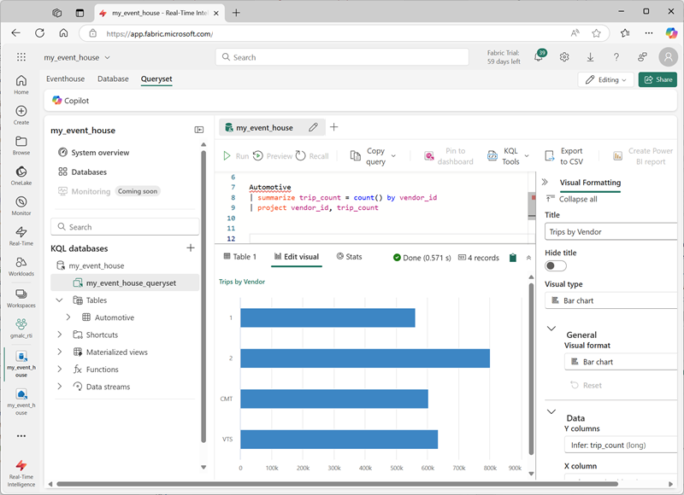

Using Copilot to assist with queries
For AI-based assistance with KQL querying, you can use Copilot for Real-Time Intelligence.
When your administrator has enabled Copilot, you see the option in queryset menu bar. Copilot opens as a pane to the side of the main query interface. When you ask a question about your data, Copilot generates the KQL code to answer your question.
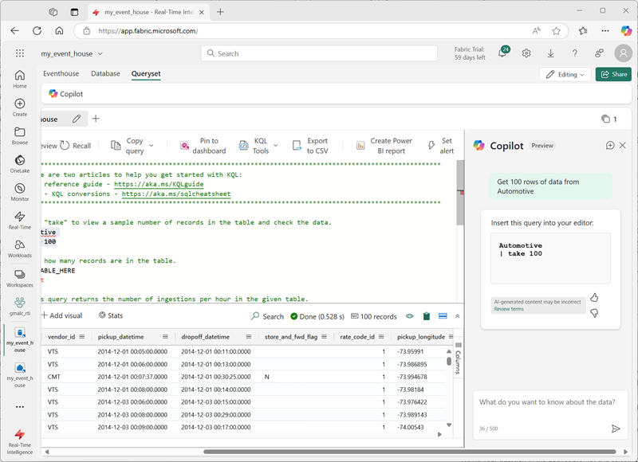

Use KQL effectively
Completed100 XP
- 12 minutes
KQL databases in eventhouses are optimized for large volumes of real-time data. To get the best results, there are some good practices you should bear in mind.
Tables based on streams of real-time data can become large. Minimizing the data returned by a query can help optimize performance and prevent errors due to exceeded data limits.

Filter columns
Use the project keyword to retrieve only the columns you need. For example, the following query returns only four columns of data:
kqlCopy
Automotive
| project trip_id, vendor_id, pickup_datetime, fare_amount

Filter rows
Use the where keyword to filter the rows returned based on specific criteria. For example, the following query returns data only for trips that occurred in the current month:
kqlCopy
Automotive
| where getmonth(pickup_datetime) == getmonth(now())
and getyear(pickup_datetime) == getyear(now())
| project trip_id, vendor_id, pickup_datetime, fare_amount
Note the use of the getmonth and getyear functions in this example. Given that real-time data usually involves a temporal (time-based) element, KQL provides strong support for filtering based on time. For example, the following query uses the ago function to restrict results to only the events that occurred in the last 30 minutes.
kqlCopy
Automotive
| where pickup_datetime > ago(30min)
| project trip_id, vendor_id, pickup_datetime, fare_amount
When the data is being perpetually loaded from a streaming source (for example, by an eventstream), you can use the ingestion_time function to filter based on when the data was loaded into the table, even if the data doesn't include a time-based value on which to filter. For example, the following query retrieves the events that have been loaded into the table in the past hour.
kqlCopy
Automotive
| where ingestion_time() > ago(1h)
| project trip_id, vendor_id, pickup_datetime, fare_amount

Summarize data
Sometimes, you don't need to retrieve data at the individual event level. Instead, you can summarize the data to help you analyze patterns - often based on time intervals.
For example, the following query retrieves the average fare collected by each taxi vendor each hour in the events ingested within the last day.
kqlCopy
Automotive
| where ingestion_time() > ago(1d)
| summarize average_fare = avg(fare_amount) by vendor_id, pickup_hour = hourofday(pickup_datetime)
| project pickup_hour, vendor_id, average_fare
| sort by pickup_hour

Materialized views and stored functions
Completed100 XP
- 12 minutes
While you can often achieve your analytical goals by querying tables and using built-in functions and operators, KQL provides some advanced features that you can use to create new objects that encapsulate data or logic that you frequently need to use.

Materialized views
A materialized view is a summary of data from a source table or another materialized view. The view encapsulates a summarize statement.
For example, the following statement creates a materialized view that contains the number of trips for each vendor each day.
kqlCopy
.create materialized-view TripsByVendor on table Automotive
{
Automotive
| summarize trips = count() by vendor_id, pickup_date = format_datetime(pickup_datetime, "yyyy-MM-dd")
}
Running this statement creates a materialized view, but doesn't immediately populate it with the data in the existing table. The view will be populated as new data is ingested into the source table. To ingest existing data, you can use an asynchronous operation to create the materialized view with the backfill option, like this:
kqlCopy
.create async materialized-view with (backfill=true)
TripsByVendor on table Automotive
{
Automotive
| summarize trips = count() by vendor_id, pickup_date = format_datetime(pickup_datetime, "yyyy-MM-dd")
}
After creating and populating the materialized view, you can query it just like a table.
kqlCopy
TripsByVendor
| project pickup_date, vendor_id, trips
| sort by pickup_date desc
Materialized views are listed in the Materialized views folder for the KQL database where you defined them in the eventhouse page.

Stored functions
KQL includes the ability to encapsulate a query as a function, making it easier to repeat common queries. You can also specify parameters for a function, so you can repeat the same query with variable values.
To create a function, use the .create-or-alter function KQL command. For example, the following function retrieves the trip ID and pickup time for trips with at least the specified number of passengers:
kqlCopy
.create-or-alter function trips_by_min_passenger_count(num_passengers:long)
{
Automotive
| where passenger_count >= num_passengers
| project trip_id, pickup_datetime
}
To call the function, use it like a table. In this example, the trips_by_min_passenger_count function is used to find 10 trips with at least three passengers:
kqlCopy
trips_by_min_passenger_count (3)
| take 10

Summary
Completed100 XP
- 1 minute
In this module, you explored how to store real-time data in Microsoft Fabric and how to query it using KQL.
Tip
For more information about KQL, see Kusto Query Language (KQL) overview.

